Log Correlation & Security Detection (Dynatrace)
Objective
In this lab you will:
- Ingest application logs
- Query and analyze error logs
- Correlate logs with detected problems
- Review runtime-detected vulnerabilities
This lab simulates a real production issue in an e-commerce application.

Lab Architecture Overview
Log Monitoring + Security Flow
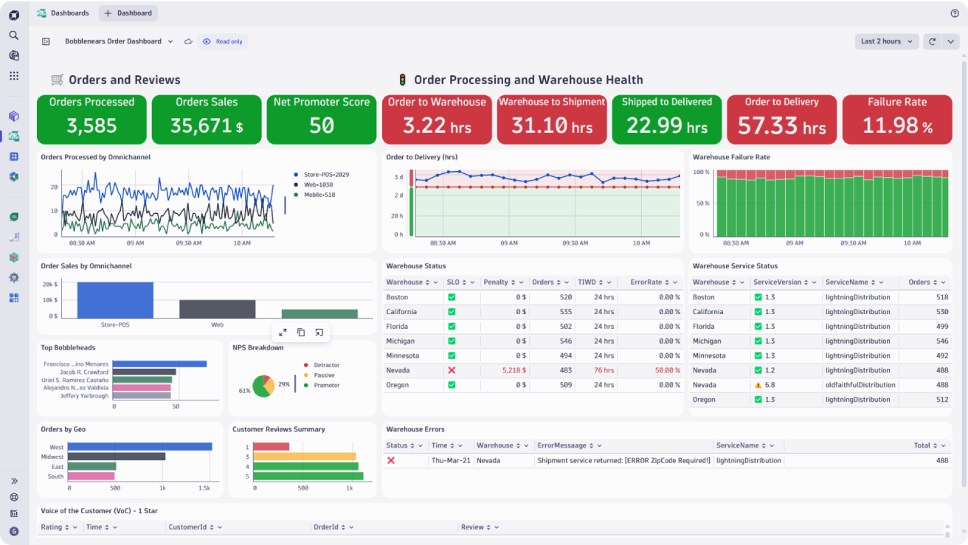
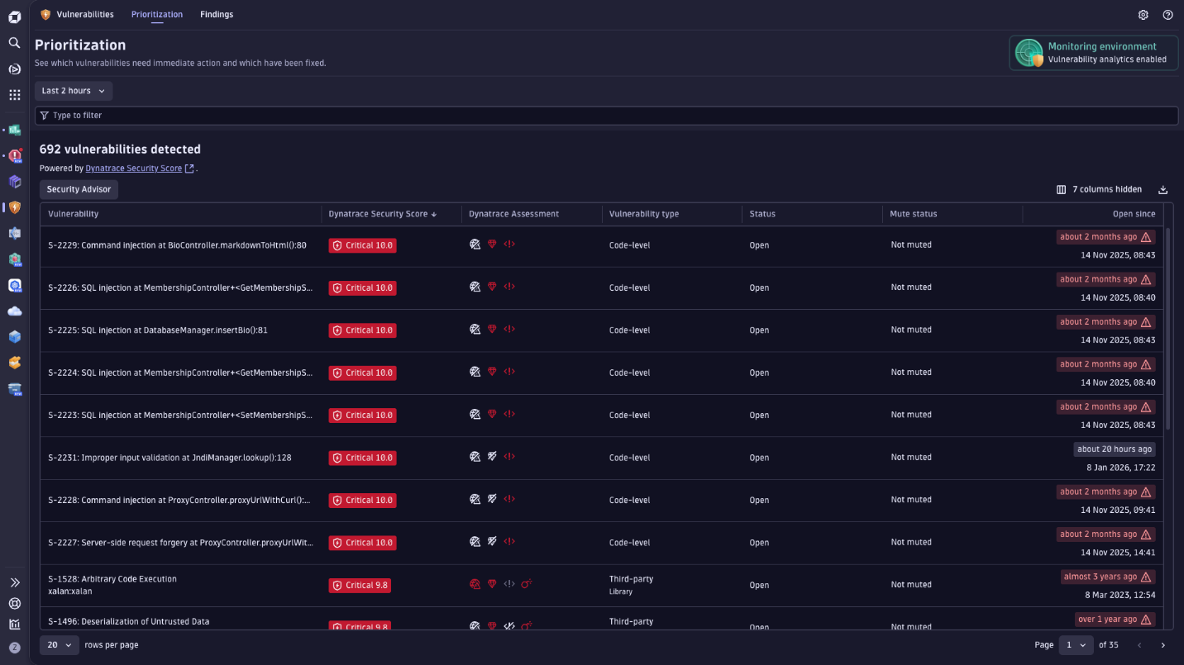
Application → OneAgent → Log ingestion → Log analytics
→ Problem detection → Security detection → Vulnerability review

Prerequisites
- Dynatrace environment (SaaS or Managed)
- OneAgent installed (VM or Kubernetes)
- Sample application (Node.js / Java / .NET)
- Log monitoring enabled

Part 1 – Ingest Application Logs
Step 1 – Enable Log Monitoring
Go to:
Settings → Log Monitoring → Log Ingestion
Enable:
- Automatic log ingestion
- Container log monitoring (if Kubernetes)

Step 2 – Verify Log Sources
Go to:
Observe & Explore → Logs
You should see:
- Application log files
- Container logs
- System logs
If logs not visible:
- Check OneAgent status
- Verify log path access permissions
- Confirm no exclusion rules applied

Step 3 – Generate Application Errors
Modify your app temporarily:
Example Node.js error simulation:
app.get("/error", (req, res) => {
throw new Error("Database connection failed");
});
Trigger:
http://localhost:3000/error
This will generate ERROR-level logs.

Part 2 – Query Error Logs
Step 1 – Open Log Viewer
Go to:
Observe & Explore → Logs & Events

Step 2 – Basic Log Query
Search:
severity="ERROR"
Filter by:
- Service name
- Kubernetes namespace
- Host

Step 3 – Advanced Query (DQL Example)
fetch logs
| filter severity == "ERROR"
| summarize count() by service
| sort count desc
This shows which service generates most errors.

Step 4 – Identify Exception Details
Search for:
content contains "Database connection failed"
Observe:
- Stack trace
- Timestamp
- Pod/host name
- Correlated trace ID

Part 3 – Correlate Logs with Problem
Step 1 – Trigger Problem Detection
Generate multiple errors (50+ requests):
http://localhost:3000/error
Dynatrace Davis AI should create:
Problem: High failure rate in checkout-service

Step 2 – Open Problem Details
Go to:
Problems → Select problem
You will see:
- Root cause service
- Failure rate spike
- Impacted users

Step 3 – View Related Logs
Inside problem view:
Click:
Related logs
Observe:
- ERROR logs automatically linked
- Timestamp aligned with failure spike
- Stack trace matching exception
This confirms correlation between:
Metrics + Traces + Logs

Root Cause Workflow
- Problem detected (high error rate)
- Click impacted service
- Open PurePath trace
- Open correlated logs
- Identify failing DB connection
This is real production troubleshooting flow.

Part 4 – Runtime Security Detection (RASP)
What is RASP?
Dynatrace Application Security provides:
- Runtime Application Security Monitoring
- Exploit detection
- Code-level vulnerability mapping

Step 1 – Enable Application Security
Go to:
Application & Microservices → Application Security
Enable:
- Runtime vulnerability analytics
- Attack detection

Step 2 – Simulate SQL Injection
Trigger test attack:
http://localhost:3000/login?username=admin' OR '1'='1
If vulnerable code exists, Dynatrace detects:
- SQL injection attempt
- Vulnerable method
- Affected service

Step 3 – Review Security Problem
Go to:
Security → Vulnerabilities & Attacks
You should see:
- Attack type (SQL Injection)
- Entry point
- Vulnerable code line
- Risk level

Part 5 – Review Detected Vulnerabilities
Vulnerability Analytics
Go to:
Application Security → Vulnerabilities
You will see:
- Third-party library CVEs
- Severity (Critical / High / Medium)
- Exploitability status
- Runtime exposure

Analyze CVE Details
Click vulnerability:
You can review:
- CVE ID
- Affected library version
- Risk score
- Remediation guidance
Example
Library: express 4.x
CVE detected: Authentication bypass vulnerability
Dynatrace shows:
- Whether used at runtime
- Whether exposed externally
- Which service depends on it
This helps prioritize fixes.

Part 6 – End-to-End Scenario Exercise
Scenario:
E-commerce checkout fails intermittently.
Security team reports suspicious login attempts.
Students must:
- Detect error logs
- Query error frequency
- Open related problem
- Correlate logs with PurePath
- Identify SQL injection attempt
- Review vulnerable dependency
- Recommend remediation
Expected Observations
You should see:
- ERROR logs ingested
- Log queries returning results
- Problem created by high error rate
- Logs linked inside problem
- SQL injection detected
- Vulnerability listed in security dashboard
Troubleshooting Guide
If logs not ingested:
- Verify OneAgent running
- Check log monitoring enabled
- Confirm file permissions
If logs not correlated:
- Ensure same service tag
- Verify timestamps aligned
- Confirm trace context propagation
If no vulnerability detected:
- Ensure security module enabled
- Confirm supported runtime
- Trigger realistic exploit attempt

